Mail Transfer Agent (MTA)

📦 What is a Mail Transfer Agent (MTA)?
# Source: AI Source: Provided by: [Data Path: Persons Table -> ID Column: 1, Name_En Column: Motasem Essam] -> From: [Chatgpt (GPT‑5 Mini)] on [1/21/2026]
A Mail Transfer Agent (MTA) is software that sends, routes, and delivers email messages from one server to another — using the SMTP protocol.
Think of it as the post office in the world of email.

🧠 Real-Life Analogy:
# Source: AI Source: Provided by: [Data Path: Persons Table -> ID Column: 1, Name_En Column: Motasem Essam] -> From: [Chatgpt (GPT‑5 Mini)] on [1/21/2026]
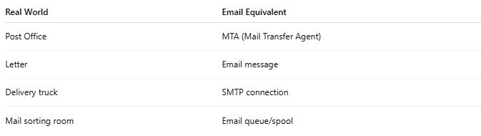

Real World | Email Equivalent
Post Office | MTA (Mail Transfer Agent)
Letter | Email message
Delivery truck | SMTP connection
Mail sorting room | Email queue/spool

🧪 What an MTA Does:
# Source: AI Source: Provided by: [Data Path: Persons Table -> ID Column: 1, Name_En Column: Motasem Essam] -> From: [Chatgpt (GPT‑5 Mini)] on [1/21/2026]
- 📤 Accepts outgoing mail from an email client (like Outlook or PHPMailer)
- 🧭 Routes the mail based on recipient’s domain (using DNS/MX records)
- 🚚 Delivers it to the recipient’s mail server (or relays it through others)
- 📨 Queues it if the recipient’s server is unreachable
- 🛡️ Applies spam checks, filtering, or policy rules (optional)

🔁 Email Flow with MTA:
# Source: AI Source: Provided by: [Data Path: Persons Table -> ID Column: 1, Name_En Column: Motasem Essam] -> From: [Chatgpt (GPT‑5 Mini)] on [1/21/2026]

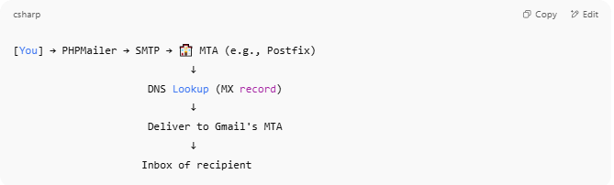

[You] → PHPMailer → SMTP → 🏤 MTA (e.g., Postfix)
↓
DNS Lookup (MX record)
↓
Deliver to Gmail's MTA
↓
Inbox of recipient

🔧 Common MTA Software:
# Source: AI Source: Provided by: [Data Path: Persons Table -> ID Column: 1, Name_En Column: Motasem Essam] -> From: [Chatgpt (GPT‑5 Mini)] on [1/21/2026]
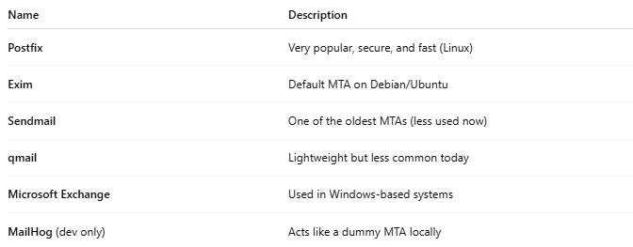

Name | Description
Postfix | Very popular, secure, and fast (Linux)
Exim | Default MTA on Debian/Ubuntu
Sendmail | One of the oldest MTAs (less used now)
qmail | Lightweight but less common today
Microsoft Exchange | Used in Windows-based systems
MailHog (dev only) | Acts like a dummy MTA locally

📝 MTA vs Other Email Components:
# Source: AI Source: Provided by: [Data Path: Persons Table -> ID Column: 1, Name_En Column: Motasem Essam] -> From: [Chatgpt (GPT‑5 Mini)] on [1/21/2026]
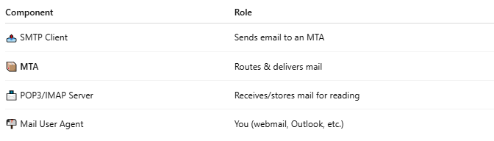

Component | Role
📤 SMTP Client | Sends email to an MTA
📦 MTA | Routes & delivers mail
📨 POP3/IMAP Server | Receives/stores mail for reading
📬 Mail User Agent | You (webmail, Outlook, etc.)

✅ Summary
# Source: AI Source: Provided by: [Data Path: Persons Table -> ID Column: 1, Name_En Column: Motasem Essam] -> From: [Chatgpt (GPT‑5 Mini)] on [1/21/2026]
A Mail Transfer Agent (MTA) is software that relays and delivers email across servers using SMTP.
Without it, emails wouldn’t leave your system or reach the recipient.

